Template and Instructions for the Preparation of Paper for PPSTA-2024

A. N. Author¹, A. Coauthor¹ and A. Third author²
1Institute of ABC, University...
2 Institute of XYZ, Institute of
E-mail of corresponding author(s): abcdefgh@yahoomail.com

Abstract

This paper should not be more than four pages including references and Author Biographic. A short abstract (summary) of your contribution may be inserted here. Use short, direct sentences. It should be as concise as possible. It should be complete, self-explanatory and should not require reference to the paper itself. The abstract should be informative, giving the scope and emphasizing the main conclusions, results, or significance of the work described. Abstract should be between 100-150 words (not characters). Submission of full paper in this template format shall be submitted before 8th September 2024.

Key Words: at least three key words shall be given

1. INTRODUCTION
This document provides a template and guidelines for authors using MS Word or similar word-processor to prepare a conference proceedings paper. Please follow the instructions carefully.

To use this file as a Word template you should save it to your Word User templates folder and then create a new document based on the template.

1.1 TITLE, AUTHOR AND ABSTRACT

1.1.1 TITLE
For the title of the paper use style ‘Title’: 24 pt Times New Roman bold; start at top of page, flush left, do not break words, initial capitals for main words, 12 pt space between title and author. Use styles ‘Author’ and ‘Author address’: 10 pt Times New Roman, flush left, one line space between author(s) and address(es). Use style ‘Abstract’: 10 pt Times New Roman, justified, flush left, two line space between Abstract and Author address. Make the word Abstract bold followed by a point.

Styles for three levels of headings are provided. ‘Heading 1’: 10 pt Times New Roman bold, flush left, two line space above, one line space below. ‘Heading 2’: 10 pt Times New Roman bold, flush left, one line space above and below. ‘Heading 3’: 10 pt Times New Roman bold, flush left, one line space above and below. Headings for sections and subsections of a paper should be numbered consecutively using Arabic numbers: e.g. 1, 1.1, 1.1.1 etc, except for the References section, which should not be numbered.

2. EXPERIMENTAL / THEORETICAL DETAILS
With a new document based on this template open in MS Word, prepare your paper as appropriate, using the set of styles that should now be available from the template (see below for further instructions on use of styles). Delete the text of these instructions from your final document before submission. For inserting Figures, please use Table (1 column and 2 rows) and place figure and its caption in respective cells.

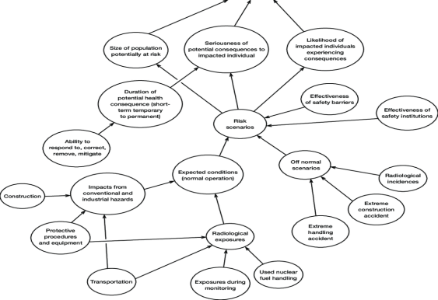
FIG. 1: This is a sample figure only (Experimental setup).
Page numbers (1.2.3, ...) should be at bottom right in the footer line. Do not include running headlines. Final book page numbers and running headlines will be added by the Publisher. The experiment set up for the present investigation is presented in Fig. 1.
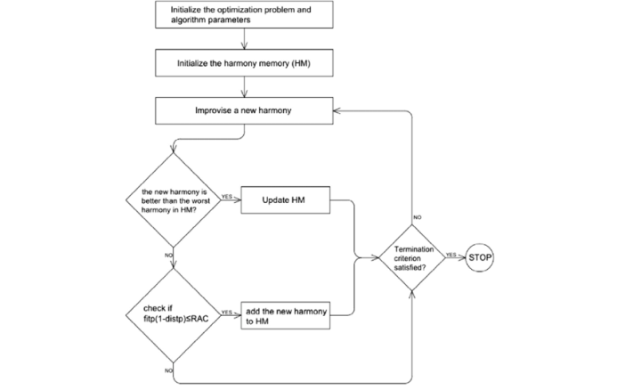
FIG. 2: This is a sample figure only (Test results).

3. EXPERIMENTAL RESULTS
This document has been set up with a set of styles that should give the correct layout automatically. For example, the heading above is in the style ‘Heading 1’. Please always use these styles. They include the spacing required between different items automatically; it should not be necessary to add blank lines. Instructions have been added here in case the styles fail or for users unfamiliar with them.

Styles are included in this template for the following elements of a paper: Title, Author, Author address, Abstract, Headings, Figure captions, Table titles, Equations, References. To access and apply the styles to a document choose Format, Styles and Formatting or use the styles drop-down list that may be visible on the standard MS Word formatting toolbar. Test results are shown in as presented in Fig. 2.

Use Times New Roman, 10 pt, justified at single line spacing for the main text. The first paragraph after a heading should be started flush left (not indented). The styles for headings do this automatically. Alternatively, the style ‘First paragraph’ can be used. The ‘Normal’ style does this automatically. Do not separate paragraphs with blank lines.

3.1 EQUATION
Use style ‘Equation’ for displayed equations. They should be centred, 6pt space above and below to the text. Equation numbers should be flush right. Please use Equation Editor to create displayed equations. Below is an example created with Microsoft Equation software:
$x=\frac{−b±\sqrt{b^{2}−4\text{ac}}}{2a}$ (1)

3.2 FIGURE
Illustrations should be included directly in the files you submit. They should be at high resolution (300 dpi). All illustrations must be numbered consecutively using Arabic numbers in bold type (e.g. Fig. 1, etc). a figure should be commensurate with the amount and value of the information the figure has to convey. Please bear in mind that colour illustrations should remain clear when printed in monochrome. Centre figures on the width of the page. Position figures at the top and the bottom of a page. Do not assemble figures at the back of your paper, but place them as close as possible to where they are mentioned in the main text. Use ‘Figure caption’ style for the figure caption: Times New Roman, 10 pt, flush left.

3.3 TABLES
Tables should be numbered consecutively (in Arabic numbers) and centred on the page width. Table headings (style ‘Table title’) should be placed above tables: 10 pt Times New Roman, 10 pt space above table heading to text. Avoid vertical lines where possible. Detailed explanations or entries should be typed directly beneath the table. Position tables at the top or bottom of a page and place them as close as possible to where they are mentioned in the main text.

4. CONCLUSION
Please include all the important outcomes of your research/study in this section.

5. ACKNOWLEDGMENTS
Do not force the References section to start on a new page. Use style ‘Heading 1’ for the section heading and do not number the heading. For entries in the References section uses the ‘Reference’ style: 10 pt Times New Roman, justified, indent turnover lines 0.6 cm. See the example below.

REFERENCES
1. A.B. Author, C. Author and D.E. Author, J. Abbn. Vol.,
Page (Year).
2. X.Y. Author, in “Name of the book”, XYZ, Ed; (Publisher, City), Page, (Year)

